If you have any concerns please report them to one of our designated members of staff.
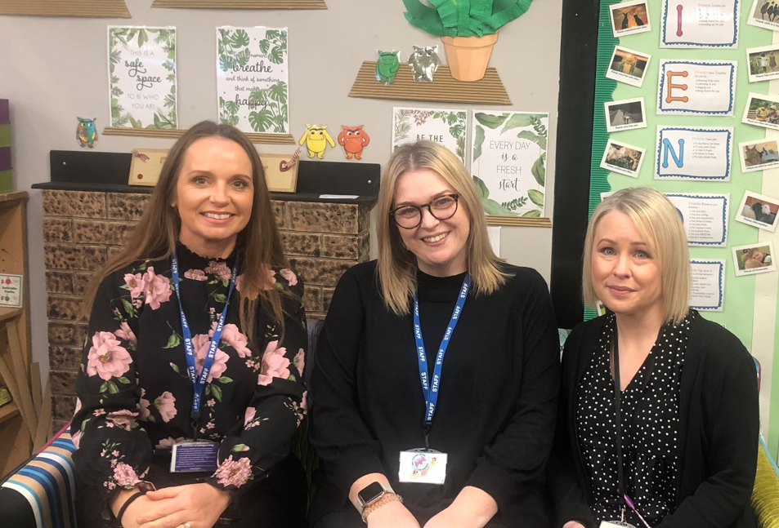
Carol Besant  Headteacher  Designated Safeguarding Lead  Prevent and Domestic Abuse Lead | Zoe Catchpole  KS1 Lead  Deputy Designated Safeguarding lead  Mental Health and Young Carers’ Lead | Charlotte Green  Teaching Assistant  Deputy Designated Safeguarding Lead  ELSA – Emotional Literacy Support Assistant

All staff to report concerns on ORANGE forms In the staffroom on sfaeguarding wall.

Local Authority
Designated Officer
(LADO)

Tel: 01223 727967

Safeguarding is everyone’s responsibility

