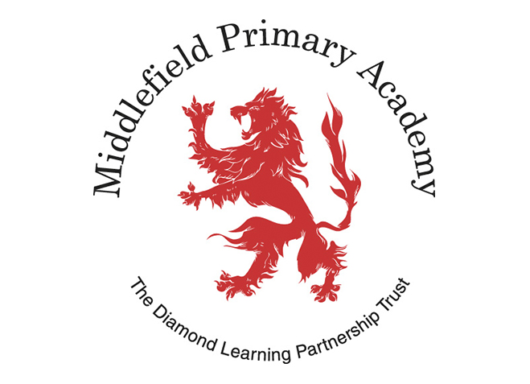

Music Intent, Implementation, Impact Statement

Intent
At Middlefield Primary Academy, we follow the Kapow scheme for Music. The scheme aims first and foremost to help children to feel that they are musical, and to develop a life-long love of music. We focus on developing the skills, knowledge and understanding that children need in order to become confident performers, composers, and listeners. Our curriculum introduces children to music from all around the world and across generations, teaching children to respect and appreciate the music of all traditions and communities.

Children will develop the musical skills of singing, playing tuned and untuned instruments, improvising and composing music, and listening and responding to music. They will develop an understanding of the history and cultural context of the music that they listen to and learn how music can be written down. Through music, our curriculum helps children develop transferable skills such as team-working, leadership, creative thinking, problem-solving, decision-making, and presentation and performance skills. These skills are vital to children’s development as learners and have a wider application in their general lives outside and beyond school.

Our scheme of work enables pupils to meet the end of key stage attainment targets outlined in the national curriculum and the aims of the scheme align with those in the national curriculum.

Implementation
The scheme takes a holistic approach to music, in which the individual strands below are woven together to create engaging and enriching learning experiences:
- Performing
- Listening
- Composing
- The history of music
- The inter-related dimensions of music

Each five-lesson unit combines these strands within a cross-curricular topic designed to capture pupils’ imagination and encourage them to explore music enthusiastically. Over the course of the scheme, children will be taught how to sing fluently and expressively, and play tuned and untuned instruments accurately and with control. They will learn to recognise and name the interrelated dimensions of music - pitch, duration, tempo, timbre, structure, texture and dynamics - and use these expressively in their own improvisations and compositions.

Our scheme follows the spiral curriculum model where previous skills and knowledge are returned to and built upon. Children progress in terms of tackling more complex tasks and doing more simple tasks better, as well as developing understanding and knowledge of the history of music, staff, and other musical notations, as well as the interrelated dimensions of music and more.

In each lesson, pupils will actively participate in musical activities drawn from a range of styles and traditions, developing their musical skills and their understanding of how music works. Lessons incorporate a range of teaching strategies from independent tasks, paired and group work as well as improvisation and teacher-led performances. Lessons are ‘hands-on’ and incorporate movement and dance elements, as well as making cross curricular links with other areas of learning.

Lessons are differentiated ensure that learning can be accessed by all pupils and opportunities to stretch pupils’ learning are given when required. Knowledge organisers for each unit support pupils in building a foundation of factual knowledge by encouraging recall of key facts and vocabulary.

Strong subject knowledge is vital for staff to be able to deliver a highly effective and robust music curriculum. Teachers are able to access videos to develop subject knowledge and support ongoing CPD, aiding them in their own acquisition of musical skills and knowledge. Further CPD opportunities is also available via webinars with our music subject specialists. Many teachers do not feel confident delivering the music curriculum and every effort has been made to ensure that they feel supported to deliver lessons of a high standard that ensure pupil progression.

Impact
The impact of our curriculum is constantly monitored through both formative and summative assessment opportunities. At the end of each unit, there is often a performance element where teachers can make a summative assessment of pupils’ learning. The children also complete an end of unit assessment known as a POP task (Proof of Progress). The POP task is completed and assessed at a delayed time after the unit has been taught to assess depth of learning. At the end of each half term, teacher judgements and any completed POP tasks are used to record attainment and uploaded to Insight Tracker.

After the implementation of this curriculum, pupils should leave primary school equipped with a range of skills to enable them to succeed in their secondary education and to be able to enjoy and appreciate music throughout their lives.

The expected impact of following the Kapow Primary Music scheme of work is that children will:
- Be confident performers, composers and listeners and will be able to express themselves musically at and beyond school.
- Show an appreciation and respect for a wide range of musical styles from around the world and will understand how music is influenced by the wider cultural, social, and historical contexts in which it is developed.
- Understand the ways in which music can be written down to support performing and composing activities.
- Demonstrate and articulate an enthusiasm for music and be able to identify their own personal musical preferences.
- Meet the end of key stage expectations outlined in the national curriculum for music.

