



Executive Headteacher: Mrs Susannah Connell BSc MA (Ed Mgt) NPQH
Headteacher: Mrs Carol Besant

1st September 2023
Dear Parents/Carers
Year 4, 5, 6 Children
Could you please indicate on the slip below the arrangements that are in place for your child at the end of each school day, even if they have been a previous home walker.
Please return to the school office by midday Monday 4th September 2023, if no form is returned your child will need collecting from school .
Thank you for your continued support.
Yours sincerely
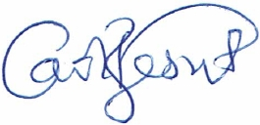
Mrs C Besant
Head Teacher
on behalf of Middlefield Primary Academy (part of TDLPT)

..................................................................................................................................
At 3.15pm the following arrangements have been made for my child:
Name: ....................................................................Year: ...........................................
□ My child will be collected by: .............................................................................
□ I give permission for my child to walk home.

