



Executive Headteacher: Mrs Susannah Connell BSc MA (Ed Mgt) NPQH
Headteacher: Mrs Carol Besant

5th September 2023

Dear Parents/Carers
Please could you indicate on the slip below the arrangements for collection that are in place for your child at the end of each school day. (Not required if you have already sent in the home walker form for Year 4, 5 & 6)
Please return to the school office by Friday 8th September.
Thank you for your continued support.
Yours sincerely
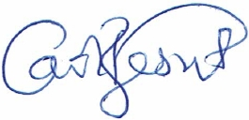
Mrs C Besant
Head Teacher
on behalf of Middlefield Primary Academy (part of TDLPT)
..................................................................................................................................
At the end of school the following arrangements have been made for my child:
Name: ....................................................................Year: ...........................................

□ My child will / can be collected by: .............................................................................
…………………………………………………………………………………………………………………………………….

Signed: ..................................................................... Parent/Carer

