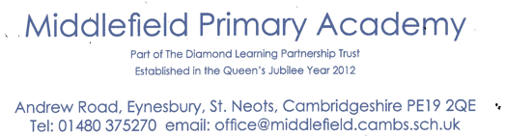



Executive Headteacher: Mrs Susannah Connell BSc MA (Ed Mgt) NPQH
Headteacher: Mrs Carol Besant

21st January 2022

Dear Parents/Carers,

The joint Eco and School Council committees will be holding a ‘Green Day’ on Thursday 10th February 2022. The children would like to raise enough funds to purchase a wormery to enhance their outside learning experience.

It is hoped that each class will be able to take part in various eco-friendly science activities/experiments throughout the day. The School Council also thought it would be a good idea to have a ‘bring and buy sale’ to reinforce the Reduce, Re-use, Recycle ethos of our school.

Please have a look to see if your child has a good quality pre-loved toy, book or game that they could donate for the sale table (each class will have their own table in the hall). NO SOFT TOYS OR TEDDIES AND ONLY GAMES WITH ALL OF THEIR PARTS PLEASE!

The children will have an opportunity to look at the various stalls and buy a ‘new’ toy or game to bring home with them. Any leftover toys will be donated to a charity that helps children, so if you have any ideas, do please let us know.
Toys can be brought into school from Monday 31st January.

WATCH THIS SPACE FOR MORE DETAILS OF THE EXCITING IDEAS AND ACTIVITIES WE HAVE PLANNED CLOSER TO THE BIG DAY!

Thank you

The Eco-committee/School Council representatives.

