Changes to Isolation Periods

The isolation period is still 10 days but can be reduced to 5 full days (as long as your child is well enough and without a temperature) and receives 2 consecutive negative LFD results. The earliest they should take the first LFD test is on day 5.

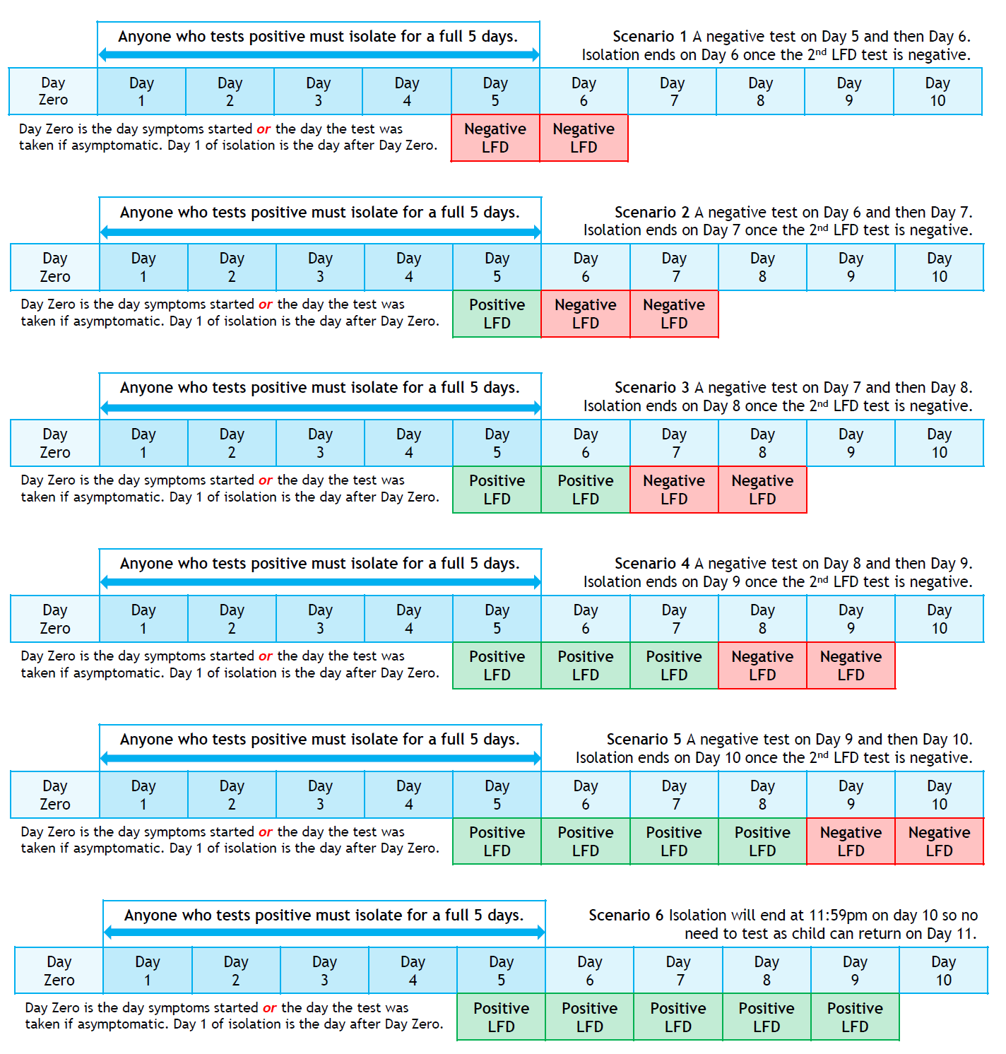
Any positive test after a first negative test would mean that the first negative is null and void. This would reset the isolation period and your child would still require 2 consecutive negative tests from this point forward. You must register results with the NHS Website here and you must e-mail both those results to school. You can order a pack of LFD tests here.

In any scenario, the isolation period can only end if your child no longer has a high temperature. This applies even if they have tested negative twice. If children still have a high temperature after Day 10, they should stay off school and seek medical advice such as contacting your GP or phoning 111.

