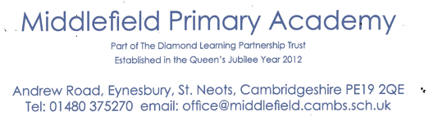



Executive Headteacher: Mrs Susannah Connell BSc MA (Ed Mgt) NPQH
Headteacher: Mrs Carol Besant
20th September 2021
Dear Parent/Carer,
I am writing to inform you that we have been notified of a confirmed case of COVID-19 within the school. (EYFS). I have also been informed of other families who are self- isolating due to confirmed cases. Therefore, please be extra vigilant with recognising any of the Covid-19 symptoms (high temperature, a new continuous cough or a loss or change to their sense of smell or taste). Should your child develop any of these symptoms, please follow stay at home guidance and inform school as soon as possible.
As with positive cases in other settings, and in line with national guidance, NHS Test and Trace will work with the individual who has tested positive to identify close contacts. This is no longer the responsibility of the school.
If your child is identified as a close contact by NHS Test and Trace, they will contact you. Your child will be advised to take a PCR test at the earliest opportunity and will only be asked to isolate for 10 days if they test positive. If the test is negative, they may continue to attend school as normal.
Children who are aged under 5 years old who are identified as close contacts would only be advised to take a PCR test if the positive case is in their own household.
If your child is advised to take a test, we would strongly encourage that they do so as this will help prevent further transmission. A PCR test can be booked by visiting www.nhs.uk/coronavirus or by phoning 119.
Thank you once again for all you are doing to keep Middlefield Primary Academy safe.
Yours sincerely,
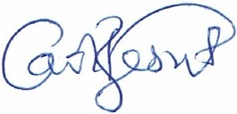
Mrs Carol Besant
Headteacher
on behalf of Middlefield Primary Academy (part of TDLPT)

