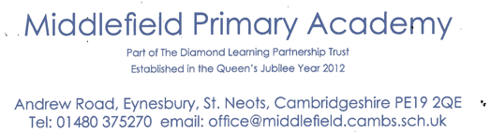

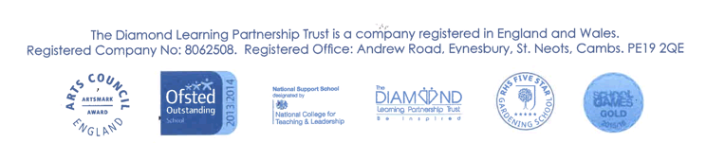

Executive Headteacher: Mrs Susannah Connell BSc MA (Ed Mgt) NPQH
Headteacher: Mrs Carol Besant
22nd July 2021
Dear Parents of Years 1 & 2 (Current Reception & Year 1)
Great Fire of London Day – Wednesday 15th September 2021
Just after we start back to school in September, we have arranged for years 1 & 2 to take part in a History Off the Page day. They will learn all about The Great Fire of London.
There are two payment options for this event:
- The cost of this one event is £8.00
- Or you may prefer to pay the annual parent contribution for 2021/2022 of £15 for the year or £5 per term (September, January & April), this event and all others (except trips out i.e. residential and day trips) throughout the school year will then be covered by the annual parent contribution.

Please pay using the reply slip attached. Payment may be via Arbor or cheque, please make cheques payable to Diamond Learning Partnership Trust.
No Cash payment will be accepted for this event.
We need to receive payment by Tuesday 14th September or your child may not be able to take part in the event.
On this day, your child will, through role play, experience life as it would have been like living through The Great Fire of London and using authentic items and materials to experience what it was like. As the day progresses, the children will get involved in the issues of the time, with the chance to participate in a range of activities. By the end of the day, they will have a really good idea of how it felt to live through The Great Fire of London.
A simple costume will help your child feel part of the day. The details are attached separately to this email, but please note that the children are taking the role of ordinary people, so weapons are not appropriate. It is also not important for the children to be particular characters from history.
Many thanks for your continued support.
Yours sincerely
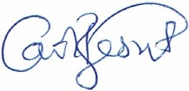
Mrs Carol Besant
Headteacher
on behalf of Middlefield Primary Academy (part of TDLPT)

Great Fire Of London Day Payment- Wednesday 15th September 2021
• I enclose a cheque for £8.00
• or a cheque for the £15 Annual Parent Contribution 2021/2022
• or my first instalment of £5 per term Parent Contribution
• I have paid one of the above via Arbor for the History off the Page Great Fire Of London Day on Wednesday 15th September 2021

Child’s name ......................................................................Year ……………...

Signed .......................................................................................................

